Computer Architecture Lab
(EL-2012)
LABORATORY REPORT

Fall 2026

(Lab#04)
Use of Venus Simulator for Register Level Execution of RISC-V Arithmetic and Memory Instructions

Student Name: __Syed Sikandar Abbas_ Roll No: _24I-6553____ Section: CE-B

Date performed: _September 9, 2026

MARKS AWARDED: ________ / 10

Signature and date of Instructor: _________________
Lab Instructors: Dr. Nasir Ali Shah, Engr. Fasih Ahmad

______________________________________________________________________________________________________________________________________________________

NATIONAL UNIVERSITY OF COMPUTER AND EMERGING SCIENCES, ISLAMABAD
Prepared by: | Fasih Ahmad |  | Version: 1.0
Verified by: | Dr. Nasir Ali Shah |  | Updated: Fall 2026
Task 1:

Description:
In this task we were required to perform arithmetic operations on registers using assembly language and simulate it in Venus Simulator. Values of A and B were initially specified and A+B, A-B, A*B, A^2 operations were to be performed. Along with it, we were also required to express the machine representation of each instruction in decimal.
Code:
.text
.data

.globl main
addi s0, x0, 5 # A
addi s1, x0, 4 # B
add s2, s0, s1 # C = A + B
sub s3, s0, s1 # D = A - B
mul s4, s0, s1 # E = A * B
mul s5, s0, s0 # F = A ^ 2

li a7, 93
li a0, 0
ecall
Output:
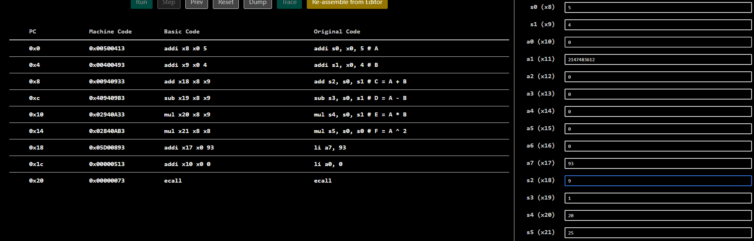
Part V:
Instruction # 1: addi s0, x0, 5
Hex = 0x500413
Decimal = (3*16^0) + (1*16^1) + (4*16^2) + (5*16^5) = 5243923

Instruction # 2: addi s1, x0, 4
Hex = 0x400493
Decimal = (3*16^0) + (9*16^1) + (4*16^2) + (4*16^5) = 4195475

Instruction # 3: add s2, s0, s1
Hex = 0x940933
Decimal = (3*16^0) + (3*16^1) + (9*16^2) + (4*16^4) + (9**16^5) = 9699635

Instruction # 4: sub s3, s0, s1
Hex = 0x409409B3
Decimal = (3*16^0) + (11*16^1) + (9*16^2) + (4*16^4) + (9*16^5) + (4*16^7) = 1083443635

Instruction # 5: mul s4, s0, s1
Hex = 0x2940A33
Decimal = (3*16^0) + (3*16^1) + (10*16^2) + (4*16^4) + (9*16^5) + (2*16^6) = 43256371

Instruction # 6: mul s5, s0, s0
Hex = 0x2840AB3
Decimal = (3*16^0) + (11*16^1) + (10*16^2) + (4*16^4) + (8*16^5) + (2*16^6) = 42209971

Instruction # 7: li a7, 93
Hex = 0x5D00893
Decimal = (3*16^0) + (9*16^1) + (8*16^2) + (13*16^4) + (5**16^5) = 97523859

Instruction # 8: li a0, 0
Hex = 0x513
Decimal = (3*16^0) + (1*16^1) + (5*16^2) = 1299

Instruction # 9: ecall
Hex = 0x73
Decimal = (3*16^0) + (7*16^1) = 115

Task 2:

Description:
In this task we were required to use the values of A and B, along with the previous task’s outputs (C,D, E, F) and combine them in a single expression to produce m as m = (A – C) + (D + E) * F.
Code:
.text
.data

.globl main
addi s0, x0, 5 # A
addi s1, x0, 4 # B
add s2, s0, s1 # C = A + B
sub s3, s0, s1 # D = A - B
mul s4, s0, s1 # E = A * B
mul s5, s0, s0 # F = A ^ 2

sub s6, s0, s2 # A - C
add s7, s3, s4 # D + E
mul s8, s7, s5 # (D+E)*F
add s9, s6, s8 # m

li a7, 93
li a0, 0
ecall
Output:
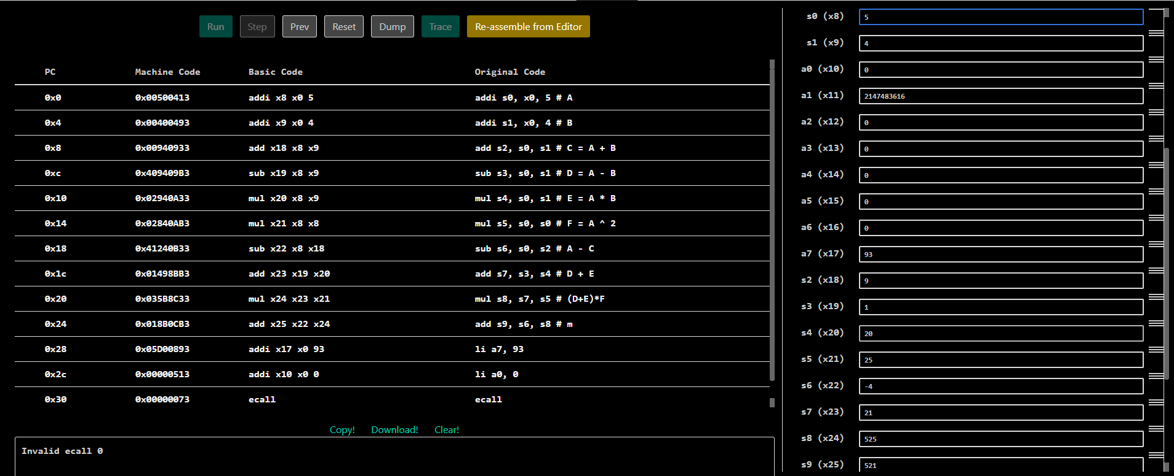

Task 3:

Description:
In this code we were required to store hexadecimal values 0xFFF and 0xF0F in two separate registers and perform AND, OR and XOR operations on those registers.
Code:
.text
.data

.globl main
li s0, 0xFFF
li s1, 0xF0F

and s2, s0, s1
or s3, s0, s1
xor s4, s0, s1

li a7, 93
li a0, 0
ecall
Output:
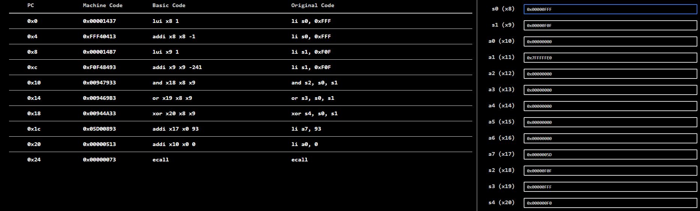

Task 4:

Description:
In this code we were given an assembly language code along with its C equivalent code. We were supposed to find out which function is being performed by the code and correct any issues in that Assembly code. The C code was given for reference.
- The assembly code was supposed to be adding the contents of an array and finally produce the sum of all the elements of the given array.
- It had .section which is not supported in Venus. It had .global but Venus supports .globl. These issues were corrected. There was no main function hence there was no array or its value. The assembler was working on garbage values and was producing unexpected outputs. So a .globl main was declared which declared stored the array address and its size and passed it onto the arraysum function.
- There were two labels each named ‘1’ and, 1b and 1f were used for branching which created ambiguity for the assembler when the .globl main was defined. These labels were changed to for and end to create seamless branching. After all these changes, the code worked fine.
Code:
.data
array:
.word 10, 20, 30, 40, 50
.text
.globl main
.globl arraysum
main:
la a0, array # a0 = pointer to array
li a1, 5 # a1 = length of array
jal ra, arraysum # Result returns in a0 (150)
li a7, 10 # ecall 10 = clean exit
ecall
arraysum:
# a0 = int a[]
# a1 = int size
# t0 = ret
# t1 = i
li t0, 0 # ret = 0
li t1, 0 # i = 0
for: # For loop
bge t1, a1, end # if i >= size, break
slli t2, t1, 2 # Multiply i by 4 (1 << 2 = 4)
add t2, a0, t2 # Update memory address
lw t2, 0(t2) # Dereference address to get integer
add t0, t0, t2 # Add integer value to ret
addi t1, t1, 1 # Increment the iterator
j for # Jump back to start of loop (1 backwards)
end:
mv a0, t0 # Move t0 (ret) into a0
ret # Return via return address register
Output:
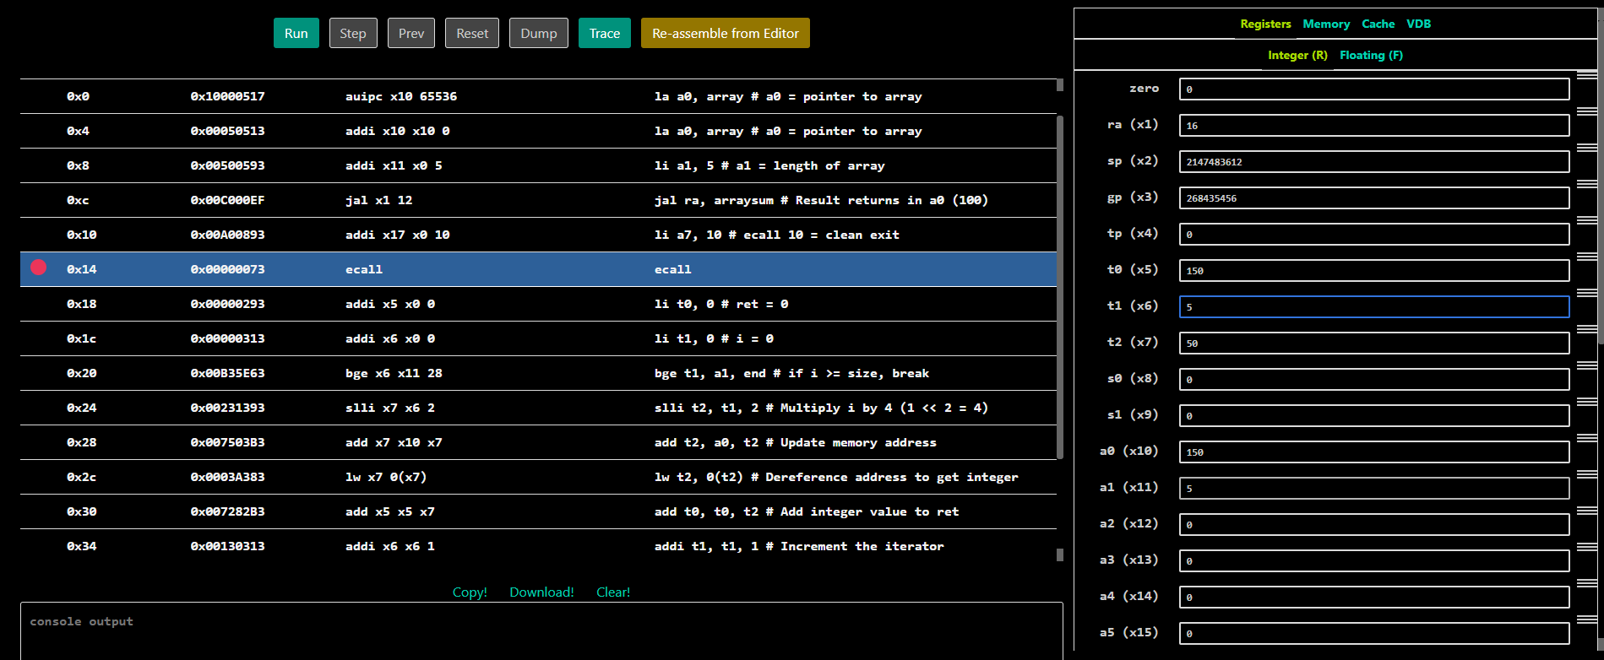

Task 5:

Description:
In this task we were supposed to store the table of two in a data type .word and store them in different registers. It declared table: .word 2, 4, 6, … , 18, 20 in .data section. Then it called the main which loads the address of the table’s first element in a1 register using la (load address) command. Then it repeatedly used lw (load word) command to load elements of the array table into saved registers from s0 to s9. Indexing was used in this code in this format: lw dest_reg, offset(base_address).
Code:
.data
table: .word 2, 4, 6, 8, 10, 12, 14, 16, 18, 20
.text
.globl main
main:
la a1, table

lw s0, 0(a1)
lw s1, 4(a1)
lw s2, 8(a1)
lw s3, 12(a1)
lw s4, 16(a1)
lw s5, 20(a1)
lw s6, 24(a1)
lw s7, 28(a1)
lw s8, 32(a1)
lw s9, 36(a1)

li a7, 93
li a0, 10
ecall
Output:
